2017 RCPA Golf Outing & Lunch

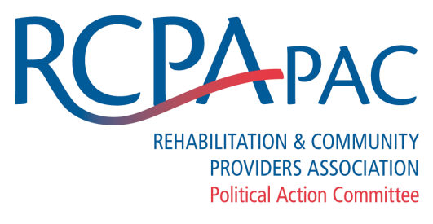

Thursday, May 11, 2017
Hershey Country Club, East Course
1000 E. Derry Rd., Hershey, PA 17033
Benefits RCPA PAC or RCPA

Registration Opens 10:30 am  Lunch 11:00 am  Shotgun Start 12:30 pm
$250 per golfer or $1,000 for a foursome
TOURNAMENT ENTRY |  | ❑ Include me in a foursome
_____________________________________________ |  | ❑ Include me with the following foursome
Golfer 1 – Name

_____________________________________________ |  | _____________________________________________
Golfer 1 – Address |  | Golfer 2 – Name
_____________________________________________ |  | _____________________________________________
Golfer 1 – City, State, Zip |  | Golfer 3 – Name
_____________________________________________ |  | _____________________________________________
Golfer 1 – email address |  | Golfer 4 – Name
To benefit PAC, make personal check payable to RCPA PAC
Otherwise, make organization check payable to RCPA TOTAL DUE: $__________________
❑ I will be unable to participate, but I have enclosed a donation to the RCPA PAC

Name: __________________________________

Address: _________________________________

City, State, Zip: ____________________________

If you are supporting the RCPA PAC, only personal checks are accepted. Otherwise, make organization check to RCPA.
No refunds for no-shows or cancellations. Substitutions are permitted.
Please return to RCPA, 777 E Park Dr, Ste 300, Harrisburg, PA 17111-2754
Phone: 717-364-3280 or email Tina Miletic

