2017 RCPA Golf Outing & Lunch

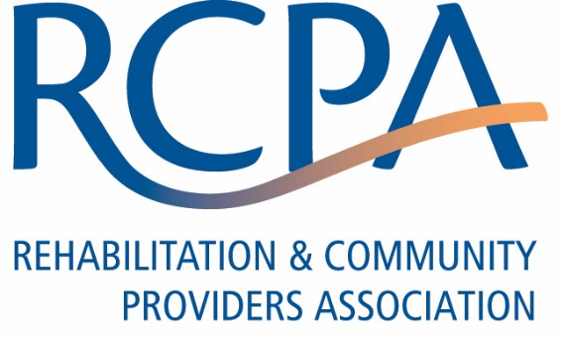
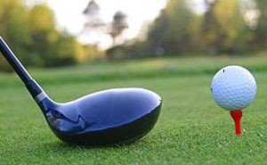

Sponsorship Opportunities
Thursday, May 11, 2017 at 11:00 am
Hershey Country Club (East Course) – 1000 West Derry Road – Hershey, PA

Tournament Sponsor (1 available) - $5,000
Display company name and logo everywhere! Banner in pavilion and on golf balls or tees. One foursome included. (Please contact Tina Miletic for availability)

Lunch Sponsor (1 available) - $3,500
Display company sign on the buffet table and banner in the pavilion during lunch. (Please contact Tina Miletic for availability)

Beverage Cart Sponsor (1 available) - $1,500
Drive around and greet all golfers. Showcase your products and services and distribute your giveaways to golfers. (Please contact Tina Miletic for availability)

Beverage Hole Sponsor (3 available) - $1,000
Greet all golfers at your sponsored hole. Showcase your products and services and distribute your giveaways to golfers. (Please contact Tina Miletic for availability)

Hole Sponsor (18 available) - $500
Personalized sponsor sign on hole.

Prize Sponsors - $250 each
________________________________________________________________________________

Company Name: ________________________________________ Contact: __________________________

Phone: ( ) ________________ Email: _________________________________________

Payment Method: Check (made payable to RCPA) Visa MasterCard

Card Holder Name: _________________________________ Card Number: __________________________

Exp: ___/____ (mm/yy) CVV Code: ______ Billing Zip Code: _________

Please return to RCPA, 777 E Park Dr, Ste 300, Harrisburg, PA 17111-2754
Phone: 717-364-3280 or email Tina Miletic

