This "Planning Template" to help you gather the information needed to complete the survey. This is an optional resource and is not required to be used. Remember that all responses must be entered into QuestionPro at https://www.questionpro.com/t/AJrvGZlLGj

Do not submit the Planning Template to ODP.

NOTE: Do not include staff that live or work exclusively in Philadelphia in your responses.

All submissions due in QuestionPro by March 8, 2021

For which ODP region(s) are you responding for this submission?
- Northeast (Berks, Bradford, Carbon, Lackawanna, Lehigh, Luzerne, Monroe, Northampton, Pike, Schuylkill, Susquehanna, Sullivan, Tioga, Wayne, Wyoming)
- Southeast (Bucks, Chester, Delaware, Montgomery)
- Central (Adams, Bedford, Blair, Cambria, Centre, Clinton, Columbia, Cumberland, Dauphin, Franklin, Fulton, Huntington, Juniata, Lancaster, Lebanon, Lycoming, Mifflin, Montour, Northumberland, Perry, Snyder, Somerset, Union, York)
- Western (Allegheny, Armstrong, Beaver, Butler, Cameron, Clarion, Clearfield, Crawford, Elk, Erie, Fayette, Forest, Greene, Indiana, Jefferson, Lawrence, McKean, Mercer, Potter, Venango, Warren, Washington, Westmoreland)

Total Number of DSPs who need to be vaccinated for this submission:

Please enter the number of staff who need a vaccine by general location provided as referenced on the map.
Disclaimer: It is important to note that this survey is for planning purposes only. There is no guarantee that ODP will coordinate clinics or that if ODP does coordinate clinics the locations indicated on the map will be selected.

Note: You will need to enter "0" into the locations that do not apply for this submission.

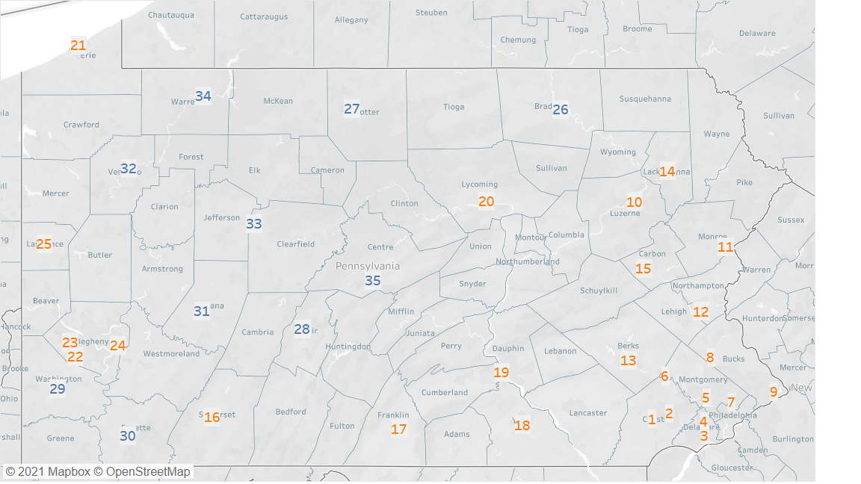

Number of DSPs who need vaccine
1. Thorndale- Southern Chester County
2. Exton- Central Chester County
3. Swarthmore- Southern Delaware County
4. Broomall- Northern Delaware County
5. Norristown- Central Montgomery County
6. Pottstown-Western Montgomery County
7. Wyncote- Eastern Montgomery County
8. Sellersville- Northern Bucks County
9. Levittown-Southern Bucks County
10. Wilkes-Barre- Luzerne County
11. Stroudsburg- Monroe County
12. Bethlehem- Lehigh County
13. Reading- Berks County
14. Dunmore- Lackawanna County
15. Nesquehoning- Carbon County
16. Somerset- Somerset County
17. Chambersburg- Franklin County
18. York- York County
19. Harrisburg- Dauphin County
20. Williamsport- Lycoming County
21. Erie- Erie County
22. Bridgeville- Southern Allegheny County
23. McKees Rocks- Western Allegheny County
24. Monroeville- Eastern Allegheny County
25. New Castle- Lawrence County
26. Towanda- Bradford County
27. Coudersport- Potter County
28. Altoona- Blair County
29. Washington- Washington County
30. Uniontown- Fayette County
31. Indiana- Indiana County
32. Oil City- Venango County
33. DuBois- Clearfield County
34. Warren- Warren County
35. State College- Centre County

Contact Information of primary contact person within agency for this submission:
- First Name
- Last Name
- Phone
- Email Address

Please provide any comments, questions, or concerns you wish to share with ODP regarding this initiative to coordinate vaccinations.

